1. **Create the following web page**
   * **Fonts used: Consolas, Edwardian Script ITC**
   * **Color: #0094ff**

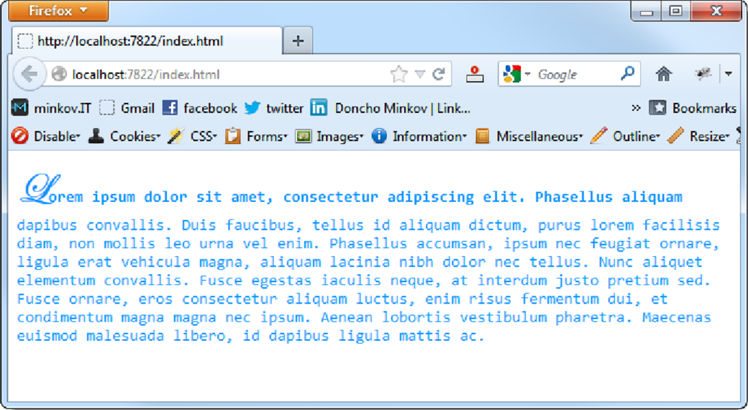

* **You are given prewritten HTML and CSS code. Expand this code to make the web page to look exactly like the PNG image:**
  + **You can find the files in 2. Homework.zip**

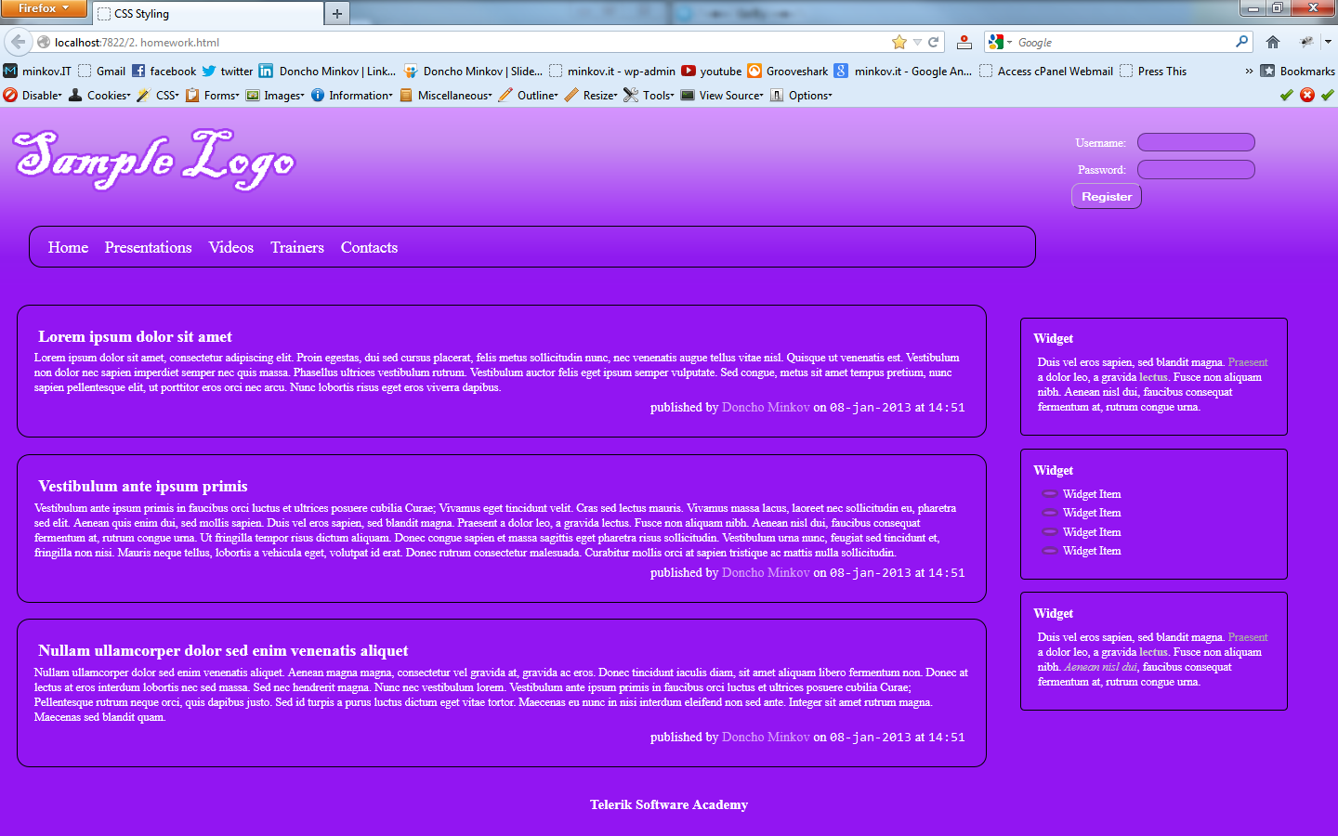

1. **Create the following web page**
   * **Using 60 nested div elements**

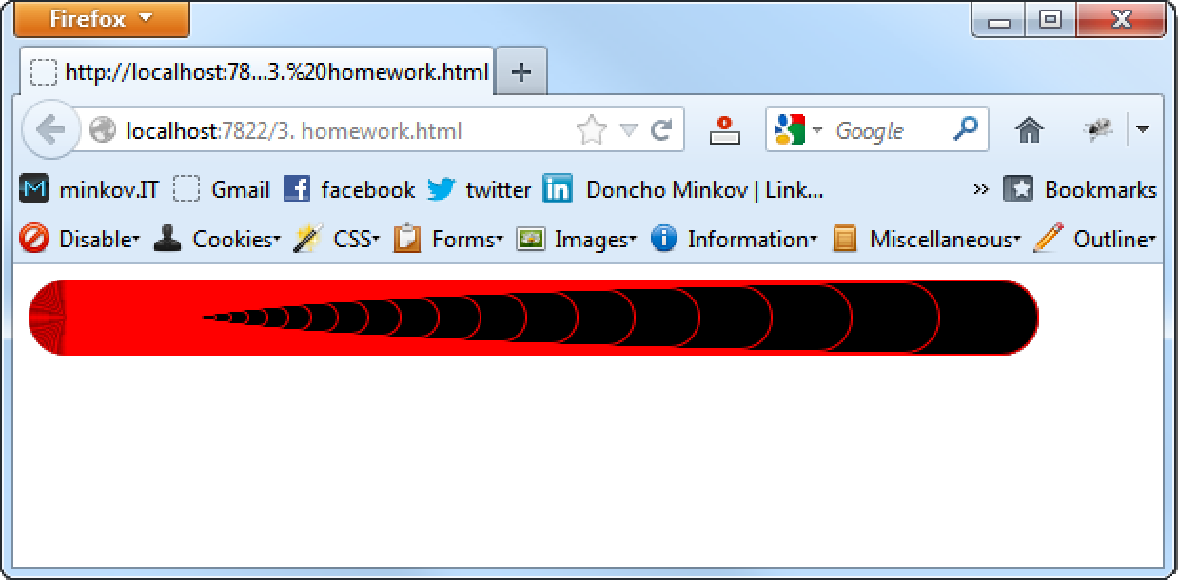

1. **Create a web page that looks like the Windows calculator in Programmer view**
   * **It should look exactly   
     the same**
   * **Implement hover effects   
     for the buttons**
   * **The calculator should   
     not have any functionality**
   * 